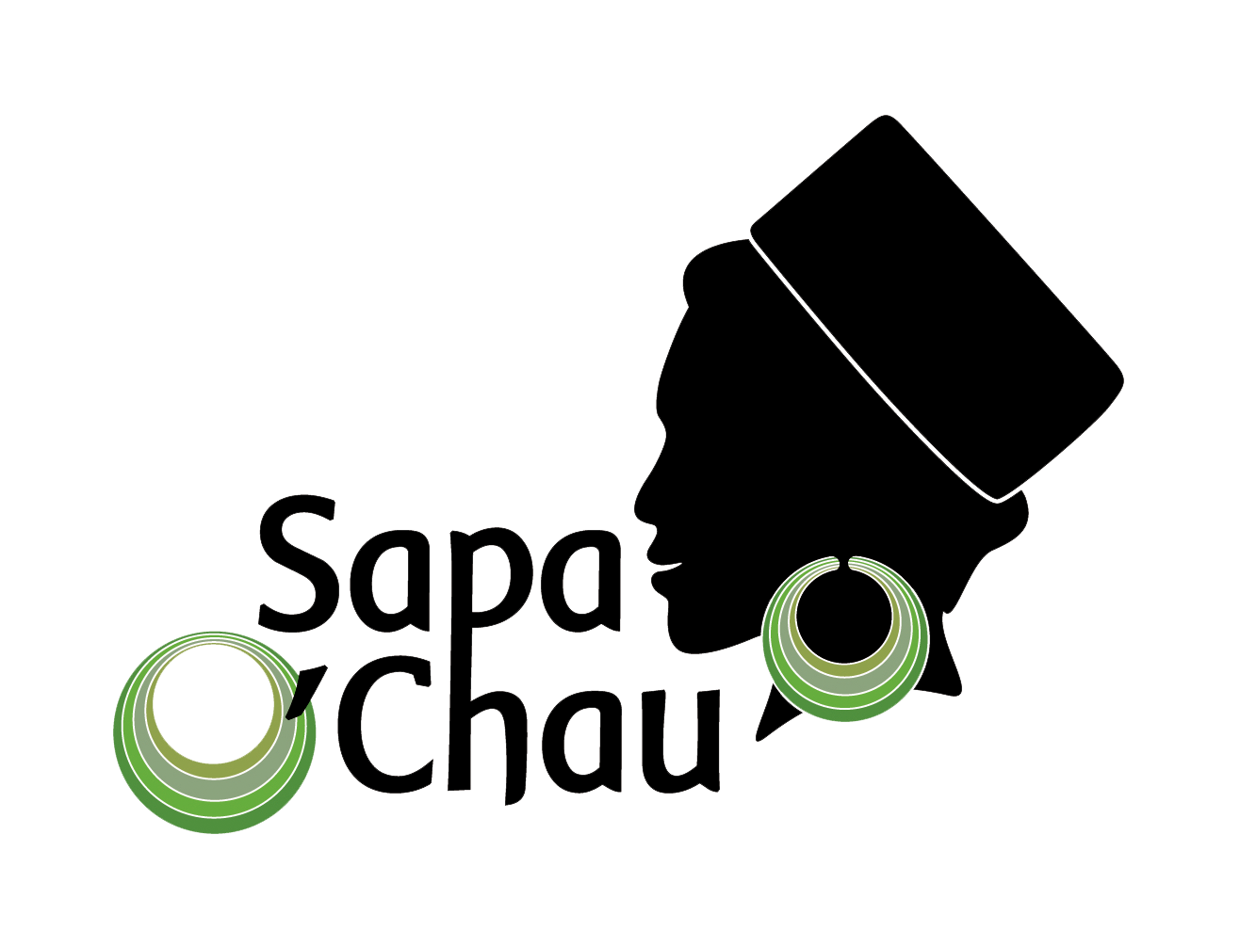Date Effective: January 2015
Date for Review: June 2017
Sapa O’Chau
Child Protection Policy
Introduction
Sapa O’Chau is committed to protecting children from harm.
Sapa O’Chau works directly with young people from disadvantaged ethnic minority groups. Our residential students, both girls and boys are from poor backgrounds with limited opportunities. They are dependent upon and trusting of Sapa O’Chau Staff and volunteers and this makes them at risk of abuse.
This policy explains the things that we expect from our people to ensure that children are protected.
Scope
This policy applies to:
- Staff
- Board of Management
- Volunteers (short and long-term)
- All visitors to the school
The policy applies at any time that staff, volunteers and others are engaged with Sapa O’Chau activities.
Definitions
Children: For the purpose of this policy, Sapa O’Chau considers a child as any individual living at the Sapa O’Chau premises for the purpose of study, regardless of age.
Senior Manager: For the purpose of this policy, Sapa O’Chau considers the following Staff as Senior Managers: Board of Management, Tour Manager, and Volunteer Manager.
Volunteer: A "volunteer" is anyone who, without compensation or expectation of compensation, performs a task at the direction of and on behalf of Sapa O'Chau. A "volunteer" must be officially accepted and enrolled by Sapa O'Chau prior to performance of the task. Unless specifically stated, volunteers shall not be considered as "employees" of Sapa O'Chau. A Volunteer may work unsupervised within Sapa O’Chau premises. Sapa O’Chau Staff may turn up unannounced to check on their work.
Visitor: is defined as any person visiting our programs or working for less than 1 week. They must be supervised by our staff at all times.
Child abuse: Both boys and girls can be the victim of child abuse, and abuse can be inflicted on a child by men, women or other children. It includes physical abuse, emotional abuse, sexual abuse, neglect or negligent treatment or commercial or other exploitation. It results in actual or potential harm to a child’s health, development or dignity.
- Physical abuse: the intentional causing of physical harm to a child. This may take the form of slapping, punching, shaking, kicking, burning, shoving, biting, strangling, poisoning or otherwise physically hurting a child.
- Emotional abuse: involves a pattern of behaviour by adults towards children, which includes threats, rejection, isolation, belittling, name calling, sexually suggestive comments or other non-physical forms of hostile or rejection treatment which erodes social competence or self-esteem over time.
- Neglect or negligent treatment: is the failure to provide a child - within the context of resources reasonably available to the family or caregivers - with the conditions essential for their physical and emotional development and well-being.
- Sexual abuse: occurs when someone uses their power or authority to involve a child in sexual or romantic activity. Sexually or romantically abusive behaviours can involve fondling, kissing, masturbation, oral sex, vaginal or anal penetration by a penis, finger or any other object, fondling breasts, voyeurism, exhibitionism or exposing the child to, or involving the child in, pornography. Both boys and girls can be victims of child sexual abuse.
- Romantic abuse: happens when an adult develops a relationship with a child beyond platonic friendship.
Code of Conduct for Working with Children
A code of conduct makes clear what is acceptable during their interactions with children. It gives adults confidence to know that their behaviours are approved if they align with the code of conduct.
Sapa O’Chau expects that all people engaged with our activities will consistently abide by the following code of conduct. They will also consistently advocate that all children are treated in these ways by others. A record of their agreement to uphold the code of conduct will be retained by Sapa O’Chau.
I understand that while involved with Sapa O’Chau, I will:
- treat children with respect regardless of race, colour, gender, language, religion, political or other opinion, national, ethnic or social origin, property, disability, birth or other status;
- not use language or behaviour towards children that is inappropriate, harassing, abusive, sexually provocative, demeaning or culturally inappropriate;
- not develop a romantic relationship with any student;
- not enter the student’s bedrooms at any time regardless of gender;
- not take the students to bars, clubs or adult-only properties, nor will I encourage this through my words or actions;
- not engage in any illegal activities at any time during my engagement with Sapa O’Chau (i.e. use illegal drugs);
- not take students outside of the Sapa O’Chau premises without explicit permission from Shu Tan or another member of the Board of Management. If permission is granted, students must be accompanied by a staff employed by Sapa O’Chau at all times;
- not encourage the students in any way to return to street selling or to leave school;
- immediately inform a Sapa O’Chau Senior Manager of any concerns that I might have in regard to the overall safety and wellbeing of any student;
- not give gifts or money to any children as this shows favouritism and encourages dependency. Instead, I will give donations to the Sapa O’Chau management to distribute;
- not engage children in any form of sexual intercourse or sexual activity, including paying for sexual services or acts;
- use any computers, mobile phones, video cameras, cameras or social media appropriately, and never to exploit or harass children or access child exploitation material through any medium;
- not use physical punishment on children;
- not hire children for domestic or other labour outside the work already conducted by the children within the Sapa O’Chau program (eg trekking, Cafe work);
- comply with all relevant local legislation, including labour laws in relation to child labour;
- immediately disclose all charges, convictions and other outcomes of an offence, which occurred before or occurs during my association with Sapa O’Chau that relate to child exploitation and abuse.
When photographing or filming a child or using children’s images for work-related purposes, I must:
- Obtain consent from Shu Tan or another member of the Board of Management before putting a picture of a child onto any social media platform
- assess and endeavour to comply with local traditions or restrictions for reproducing personal images before photographing or filming a child;
- obtain informed consent from the child and parent or guardian of the child before photographing or filming a child. As part of this I must explain how the photograph or film will be used;
- ensure photographs, films, videos and DVDs present children in a dignified and respectful manner and not in a vulnerable or submissive manner. Children should be adequately clothed and not in poses that could be seen as sexually suggestive;
- ensure images are honest representations of the context and the facts;
- ensure file labels, meta data or text descriptions do not reveal identifying information about a child when sending images electronically or publishing images in any form.
Procedures
Recruitment
Sapa O’Chau is committed to the following recruitment practices that aim to mitigate unacceptable risk to children engaged in our programs. We will:
- provide all applicants, including volunteers, with a copy of the Sapa O’Chau child protection policy during the recruitment process;
- require and keep a formal CV of all volunteers;
- require and keep a current police clearance certificate from all volunteers;
- ensure a minimum of two verbal referee checks are conducted during recruitment of all staff and volunteers;
- ask at least one question during recruitment interviews that presents a hypothetical scenario relating to child protection which the applicant must respond to;
- require all staff and volunteers to sign an acknowledgement that they have read and understood the child protection policy, and will abide by the Code of Conduct for Working with Children.
Visitors
All visitors will be required to read and follow the Code of Conduct for Working with Children
Visitors must be supervised by a staff member or volunteer at all times.
Training
Sapa O’Chau will conduct an induction session with all new staff and volunteers. This will include introducing the child protection policy and in particular, the Code of Conduct for Working with Children.
Sapa O’Chau will also arrange training with our staff on issues relevant to promoting the safety, protection and well-being of children from time to time.
Reporting Concerns
What should be reported?
Staff and volunteers must report to a Sapa O’Chau Senior Manager when they have a reasonable belief that a child has been harmed or is at potential risk of harm when it is due to the actions of a staff member or volunteer. Harm includes, but is not limited to, the forms of child abuse defined in this policy.
Cases where children have been harmed or are at risk of harm due to the actions of someone not associated with Sapa O’Chau (in the community) should also be reported.
Concerns that must be reported include:
- An observation or disclosure of actual harm or abuse to a child;
- An observation or disclosure of potential risk of harm to a child;
- A breach of the Child Protection Policy or Code of Conduct for Working with Children;
- An observation of possession of child exploitation material.
Sapa O’Chau also expects staff and volunteers to be observant for indicators of child abuse and to raise concerns, even in the absence of a disclosure.
If you are not sure if what you have seen or heard is harm or risk of harm to a child, talk to a Sapa O’Chau Senior Manager.
Who do you need to report to?
A report must be made to one of the following (in order of priority):
- Shu Tan, Founder
- Thao Cau, Director
- Dung Cu, Board Member
- Dung Ha, Tour Operations Manger
How do you make a report?
Reports can be made in person or by telephone as soon as possible. Verbal reports should be followed up with written notification within 24 hours (Please CC shu@sapaochau.org, cau@sapaochau.org)
What do you need to include in the report?
You should provide as much objective information as possible, including:
- Dates, times, form of communication of disclosure;
- Names of people/organisations involved;
- Details of alleged incidents;
- Which authorities have/will be informed;
- Activities/interventions already undertaken;
- Support services engaged;
- Details of what Sapa O’Chau proposes to do ;
- Any other relevant information.
Responding
Once a report has been received, a full investigation will be conducted by Sapa O’Chau Senior Managers and then action taken. All information provided in a report will be treated confidentially and professionally. A decision to notify police or other relevant authorities will be based on the type of concern reported, legal responsibilities and the best interests of the child/children involved. A decision to suspend a staff member or volunteer may be taken while an investigation is underway, however Sapa O’Chau will ensure that this process is just and fair.
The following advice should be followed in the event that a child discloses a concern to staff or volunteers.
- Remain calm and in control of your feelings;
- Tell them that you believe them;
- Listen carefully to what they are saying;
- Don’t ask lots of questions - listen to what they want to tell you;
- Tell them it is not their fault and you are pleased that they told you as you can now do something about it;
- Take steps to distance the alleged perpetrator from the child.
Consequences
Sapa O’Chau is committed to preventing a person from working with children if they pose an unacceptable risk to children.
When reported, a formal investigation will be undertaken by Sapa O’Chau Board of Management. If a person is found to have not followed the Code of Conduct for Working with Children it will lead to disciplinary actions.
For minor violations, the staff member or volunteer will be warned.
For major violations, staff may be dismissed or transferred to other duties. Volunteer relationships may be terminated.

